**SPMP for OTT PLATFORM**

**Bachelor of Technology**

**Computer Science and Engineering**

Submitted By

AYUSH DEV

(13000121011)

NOVEMBER 2023



**Techno Main**

**EM-4/1, Sector-V, Salt Lake**

**Kolkata- 700091**

**West Bengal**

**India**

**Table of Contents**

1. Introduction 3

I. Project Overview 3

II. Project Deliverables 3

III. Evolution of this document 3

IV. References 4

V. Definitions, Acronyms, and Abbreviations 4

2. Project Organization 4

I. Process Model 4

II. Organizational Structure 5

III. Organizational Boundaries and Interfaces 6

IV. Project Responsibilities 6

3. Managerial Process 7

I. Management Objectives and Priorities 7

II. Assumptions, Dependencies, and Constraints 7

III. Risk Management 7

IV. Monitoring and Controlling Mechanisms 8

4. Technical Process 8

I. Methods, Tools, and Techniques 8

II. Software Documentation 9

III. Project Support Functions 9

5. Work Elements and Budget 9

6. Conclusion 9

7. Schedule 10

**Software Project Management Plan for “OTT Platform”**

# Introduction

An OTT platform (Over-The-Top platform) is a digital streaming service that delivers video content, audio, and other media directly to users over the internet. The project aims to develop and launch an online OTT platform to provide users with a seamless streaming experience. The primary purpose of this Software Project Management Plan (SPMP) is to provide an in-depth overview of how we intend to manage this project. It encompasses the methodologies and strategies we will employ to ensure the successful delivery of the OTT platform.

## Project Overview

The project aims to create and launch an innovative Over-The-Top (OTT) platform tailored for the Indian market. This OTT platform will provide a diverse range of streaming content including movies, TV shows, documentaries, and original productions. It will provide flexibility in terms of subscription plans, allowing users to choose the content they want to watch and pay for specific services, unlike traditional cable packages.

## Project Deliverables

1. Preliminary Project Plan 01.09.2023

2. Requirements Specification 20.09.2023

3. Analysis [Object model, Dynamic model, and User interface] 15.10.2023

4. Architecture Specification 30.11.2023

5. Component/Object Specification 25.12.2023

6. Source Code 25.12.2023 - 01.02.2024

7. Test Plan 01.02.2024 - 05.03.2024

8. Final Product Demo 05.03.2024 - 10.04.2024

## Evolution of this document

This document will evolve as the project progresses, with updates in the following sections:

1. ***References*** - updated as needed.
2. ***Definitions, acronyms, and abbreviations*** - updated as necessary.
3. ***Organizational Structure*** - adjusted as team leaders are assigned for each phase.
4. ***Technical Process*** - updated to reflect evolving requirements and design decisions.
5. ***Schedule*** - as the project progresses, the schedule will be updated accordingly.

|  |  |  |  |
| --- | --- | --- | --- |
| **Revision** | **Date** | **Updated By** | **Update Comments** |
| 0.1 | 01.09.2023 | Ayush Dev | First Draft |
| 0.2 | 15.11.2023 | Ayush Dev | Second Draft |

**Revision History**

## References

* + 1. <https://www.studocu.com/>
    2. <https://www.academia.edu/>
    3. <https://www.coursehero.com/>
    4. <https://www.netflix.com/in/>

## Definitions, Acronyms, and Abbreviations

* OTT - Over-The-Top
* UML - Unified Modeling Language
* AD - Architectural Design
* PM - Project Manager
* Dev - Development Team
* UX - User Experience
* UI - User Interface

# Project Organization

## Process Model

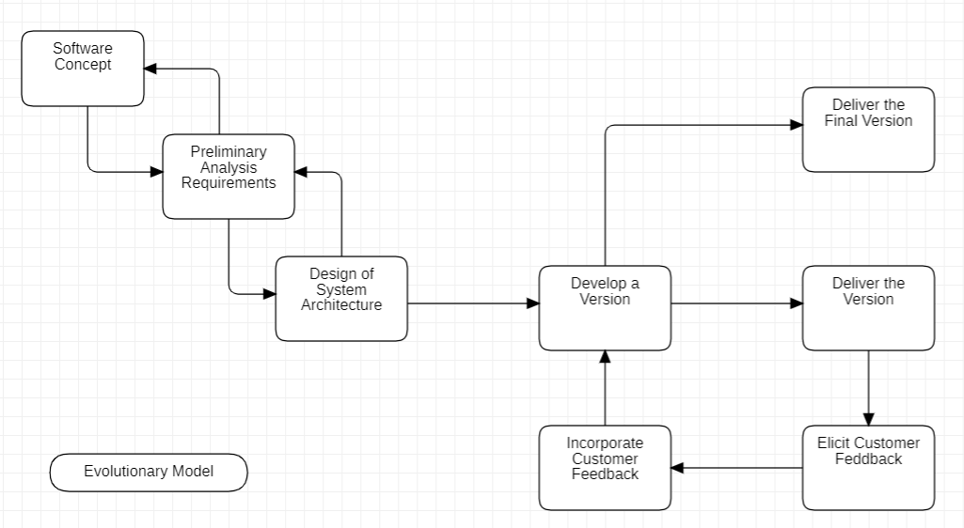

The process used for this project will be an Evolutionary model considering the dynamic and user-centric nature of this industry. It allows for continuous improvement, adaptation to changing requirements, and early user involvement, all of which are valuable for creating a successful OTT platform.

## Organizational Structure

Team Members –

* + 1. Ayush Dev
    2. Aadarsh Sharma

|  |  |  |
| --- | --- | --- |
| **Name** | **Organization/**  **Position** | **Contact Information** |
| Ayush Dev | Project Manager | [devayushya@gmail.com](mailto:devayushya@gmail.com)  9162344524 |
| Aadarsh Sharma | Business Analyst | [aadarshsharma@gmail.com](mailto:aadarshsharma@gmail.com)  7384222110 |
| Ayush Dev | Tech Designer | [devayushya@gmail.com](mailto:devayushya@gmail.com)  9162344524 |

|  |  |  |  |
| --- | --- | --- | --- |
| **Days** | **Deliverable** | **Team Leader** | **Deliverable Description** |
| 20 | 1 | Ayush Dev, Aadarsh Sharma | Project Plan |
| 25 | 2 | Ayush Dev | Requirements Specification |
| 45 | 3 | Aadarsh Sharma | Analysis |
| 25 | 4 | Ayush Dev | Architecture Specification |
| 20 | 5 | Aadarsh Sharma | Component/Object Specification |
| 35 | 6 | Ayush Dev | Source Code |
| 30 | 7 | Ayush Dev | Test Plan |
| 20 | 8 | Ayush Dev, Aadarsh Sharma | Final Deliverable |

## Organizational Boundaries and Interfaces

Team leaders throughout each development of the phases will be responsible for coordinating team meetings, updates, communications, and team deliverables.

## Project Responsibilities

For the most vital responsibilities per phase of each team members, please refer to segment 2.2. Ultimately the project team is responsible for the successful delivery of the product. The team member tasks per deliverable according to expertise and the phases are as given below:

1. Project Plan – Whole Team
2. Requirements Specification – Ayush Dev
3. Analysis – Aadarsh Sharma
4. Architecture Specification – Ayush Dev
5. Component/Object Specification – Aadarsh Sharma
6. Source Code – Ayush Dev
7. Test Plan – Ayush Dev
8. Final Deliverable – Entire Team

|  |  |  |
| --- | --- | --- |
| **Name** | **Organization/Position** | **Role/Responsibilities** |
| Ayush Dev | Project Manager | * Managing and leading the project team. * Developing and maintaining a detailed project plan. * Monitoring project progress and performance. * Managing project evaluation and dissemination activities. |
| Aadarsh Sharma | Business Analyst | * Prepare reports on project plans, status, progress, risks, deadlines and resource requirements. * Develop and perform work flow analysis to find out the difficulties in reaching goals. * Provide project cost estimates. |
| Ayush Dev | Tech Designer | * Propose effective design solutions to meet project goals. * Prepare design layouts and sketches according to company design standards. * Keeping of records and files |

# Managerial Process

## Management Objectives and Priorities

The management objective is to deliver the product in time and of high quality. The PM and QAM work together to achieve this by respectively checking that progress is made as planned and monitoring the quality of the product at various stages.

## Assumptions, Dependencies, and Constraints

In this project plan, a number of factors are taken into account. The following list shows the way milestones on various project phases have been scheduled:

• The project time of 2 persons x 2500 hours = 5000 hours

• The project deadline of April 11th.

• The final presentation is on Mar 30th.

• The peer evaluation deadline is on Mar 20th.

• Other days the weekends holiday is closed (September 5th, September 12th, September 19th, October 26th, November 3rd, November 10th, November 17th, December 24th, December 31th, January 7th, January 21th, January 28th, February 5th, February 12th, February 19th, February 27th).

NOTE: Due to the deadline of 11th April 2024, running out of time will have its reflection on the product, and not on the duration of the project. By assigning a priority to every user requirement, a selection can be made of user requirements that may be dropped out if time runs out.

## Risk Management

This section mentions any potential risks for the project. Also, schedules or methods are defined to prevent or to reduce the risks as below:

* + 1. Technology risk
    2. People risk
    3. Financial risk
    4. Market risk
    5. Structure/process risk

The following are the possible risks to be encountered during the development of

the project and how they can be prevented:

* + 1. Miscommunication

*Prevention*: Team members should not hesitate to ask and re‐ask questions if things are unclear. Team members should have a written copy of the tasks assigned to them every meeting.

*Correction*: When it becomes clear that miscommunication is causing problems, the team members should gather in a meeting to clear things up.

* + 1. Time shortage

*Prevention*: Care is taken to plan enough spare time.

*Correction*: When tasks fail to be finished in time or when they are finished earlier than planned the project planning is adjusted.

* + 1. Illness or absence of team members

*Prevention*: Team members should warn their team leader or the PM timely before a planned period of absence.

*Correction*: Work can be taken over quickly by someone else or be distributed among the team members if a person gets ill.

## Monitoring and Controlling Mechanisms

The monitoring of progress is done by the PM using the following means:

* + 1. Project Kick-off Meetings

The project group meetings take place within the class room or through chat. These

meetings are meant to inform each other of the progress made on various tasks and

to assign new tasks.

* + 1. Progress Report

Progress report is done every Friday. This is meant to inform and show the progress

in the development of the project and how things are going.

* + 1. Weekly project status meetings
    2. Shared document repository
    3. Project tracking by MS project plan
    4. Tracking utilizing baselines in MS project

# Technical Process

## Methods, Tools, and Techniques

The project will be implemented utilizing Evolutionary model methodology, and tools such as Dreamweaver, Microsoft Project, Star UML, Java, MySQL, QTP, and Load Runner will be utilized. The risks for each category are listed to complete the project successfully. For each risk, a description, a probability of occurrence, the associated action and the impact of the risk are given.

## Software Documentation

Documentation such as Project Charter, Business Requirement Document, Functional Specification document, Cost Benefit Analysis, Technical Specification document, Detail Design Document, Test Plan, Implementation Plan, Detailed Project Report, and Benefit Realization document.

## Project Support Functions

All project support documents will be completed in applicable phases.

# Work Elements and Budget

* 1. The project is accounted for project resources, technologies and tools required to whole analysis, implementation, and test of the application.
  2. The project lead will be rotated for each phase within 5 team members.
  3. The document for all phases will be revised in subsequent phases if applicable.

Budget and Resource Allocation

Salary 2,50,000.00

Office Operations/Supplies/Equipment/Consumables 60,000.00

Miscellaneous 54,614.00

**Total Rs. 364,614.00**

# Conclusion

This Software Project Management Plan (SPMP) serves as a comprehensive

roadmap for the development and management of our OTT (Over-The-Top)

platform. Throughout this document, we have outlined the strategies,

methodologies, and processes that will guide our project from inception to

completion. The document outlines a cohesive roadmap for our team, stakeholders,

and project contributors.

We've established a well-structured project team, with clearly defined roles and

responsibilities, ensuring an efficient workflow. The project timeline and

milestones have been laid out, demonstrating the commitment to a well-defined

schedule while remaining adaptable to evolving requirements.

# Schedule

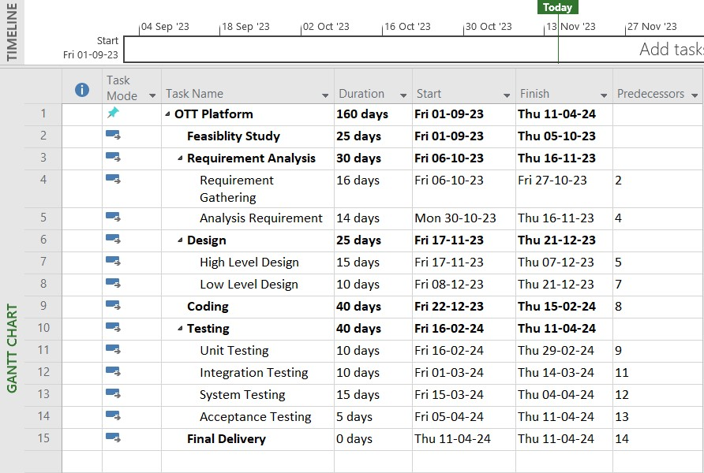

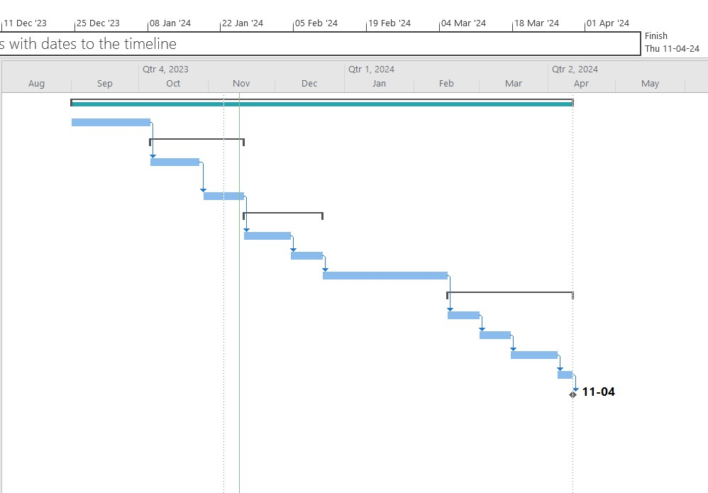

(Date Format: DD/MM/YYYY)